JIM PATCH

REMINSCENCES OF
THE LONG RANGE DESERT GROUP

- 1940–1943

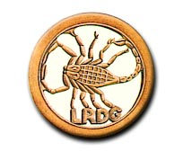

"NON VI SED ARTE" -- "NOT BY STRENGTH, BY GUILE"

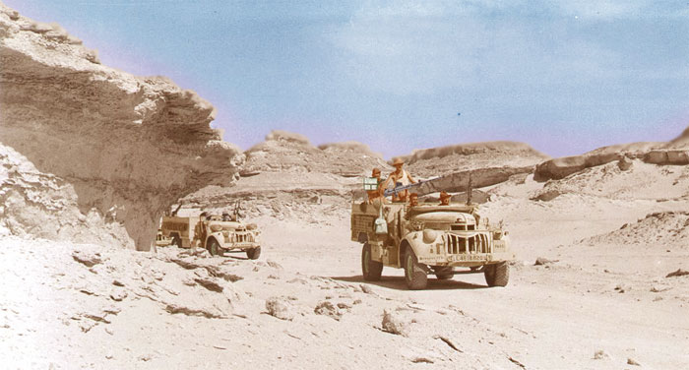

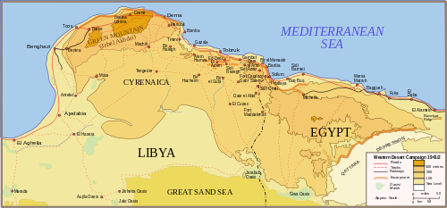

LONG RANGE DESERT GROUP AREA OF OPERATIONS
1940–1943
The Evergreens recently hosted a presentation by Jim Patch of his experiences as a young soldier with the Long Range Desert Group during the Second World War. An amazing tale unfolded as Jim, a modest and gentle man by any standard, recalled those years.

When war was declared in 1939, Jim had been working as a counter clerk in the General Post Office in Loughton, Essex, passing his clerical exams and moving to the Engineer-in Chief’s office. (The head office of what is now BT.)

"I thought that the GPO might not keep my job open if I volunteered for military service," he says. "So I decided to wait until I was conscripted - which I duly was on 16th May 1940."

He was just nineteen years old.

Upon call-up he was sent to Scarborough to be trained as a Royal Artillery (RA) signalman. In his batch of 25 men, he was issued with uniform, boots, and a steel helmet; and a weapon consisting of a Short Lee-Enfield rifle with 50 rounds in a cardboard box.

During this initial training at Scarborough, it became apparent that there was more emphasis on drill, including use of the rifle, than on signalling. The Lee-Enfield was liable to inflict more wounds on its user than on the enemy; the back sight of the weapon had a habit of catching on the user's thumb, and his sergeant used to say: "If you ain't bleeding you ain't bleeding trying!"

Jim and his colleagues were usually sent after dark up to Scarborough Castle, to defend it overnight; but far from getting some sleep after such night watches, they then had to report in the morning for injections (cholera, etc.)

It seemed to be rifle drill, day in and day out.

After some weeks, he was posted to Wakefield. Training for signalling took place over several months and finally Jim emerged as a RA Signalman, competent in radio usage, the Morse code, the riding of a motorbike and the driving of a medium truck.

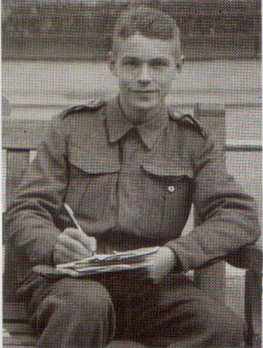

Jim was then sent to Derby to await his posting to a RA Regiment.

After a spell in Derby, he was posted to Liverpool to join the ex-Royal Mail Line liner "Andes", now converted to a troopship, to proceed to Africa.

"The "Andes" had been a passenger vessel, but now the beds and fittings had all been cleared out and hammocks installed. It was crowded, hot and stuffy," says Jim. "We had blankets with us, and most of us decided to sleep up on deck."

To evade enemy submarines, "Andes" steamed in convoy way out into the Atlantic, half-way between Africa and America, then turned to proceed to Freetown and then Durban.

Once in Durban, they were transferred to another vessel, "Mauritania", in which they steamed north past the coast of East Africa and through the Red Sea to Port Taufiq on the Suez Canal, where there was an RA depot.

"The depot consisted of square tents set up in sand, and they were infested with bedbugs."

Whilst there in the depot, Jim saw a notice on the Order Board calling for volunteers in a mysterious organisation called the 'Long Range Desert Group'.

Jim and his friend Bill Morrison thought this a good idea - anything to get out of the tedium of the camp. So together, they volunteered.

"We were taken in a 15 cwt truck out into the desert, about 200 miles from Cairo, and around 150 miles from the coast, to a place called Siwa Oasis which was in Egyptian territory but close to the border with Libya. It was about 20 square miles, consisting of 12 little oases with lakes and palm trees. It was the most beautiful place."

There, Jim met with the Long Range Desert Group. He learned that the LRDG's function was to penetrate hundreds of miles behind the enemy line to undertake reconnaissance, intelligence gathering and charting of the interior. It often meant observing enemy transport using the coast road from Tripoli to Benghazi, this route being the sole means of transit for heavy vehicles. (The "Road Watch".) If the opportunity arose and the circumstances were right, enemy convoys were ambushed and attacked. It was arduous and dangerous work where the results were usually not immediately apparent.

The LRDG was made up of ten groups of fifteen to twenty men known as patrols. There were four patrols of New Zealanders, two of Rhodesians, two of men from the Brigade of Guards and two from Yeomanry Regiments. Jim and Bill Morrison were to join a new group of six men who manned a 25-pounder field gun mounted portee on a ten ton lorry. The patrols had 30 cwt vehicles with reinforced springs and no protective armour – for lightness and speed. Weapons consisted of a variety of machine guns. The 25-pounder group was known as the RA Section.

Physical fitness and self reliance was necessary, but the LRDG personnel needed also to have the capacity to fit in well with their fellows. Every person trained to be a specialist in some role, such as navigator, wireless operator or medic; but also was trained to take on someone else’s speciality. Irrespective of rank, everyone had to pull his weight and know not only his but others’ business. Familiarity with every weapon with which the Group was equipped was expected. These were ground-breaking approaches to training at the time.
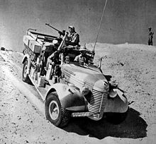

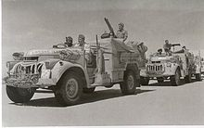

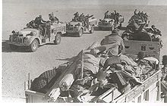
Soon the RA Section was ordered to accompany one of the Rhodesian patrols to capture and render unusable a fort built by the Italians during their occupation of Libya, called El Gtafia. It lay about 400 miles from Siwa, about 100 miles from the coast south of Agebabia. The Rhodesians’ navigator planned a route skirting the Sand Sea and the journey was completed without incident or attack from enemy aircraft or ground forces.

A circumspect approach was made to the fort. The 25-pounder and its truck were hidden behind a hill a short distance from the fort, and Jim and the patrol leader, an officer, climbed the hill to observe the building, Jim unreeling a telephone wire leading back to the gun position. The officer directed fire on the fort using the phone, and quite quickly the garrison, comprising four terrified Italians, were seen to desert the building.

“We moved in and captured the fort, and spent some time destroying fittings band equipment that we found there before pulling out.”

This was Jim’s and Bill Morrison’s first experience of action against the enemy but it took place in such a quiet and remote part of the world that neither man felt much sense of drama or excitement.

The 10-ton truck gave trouble on the way back; it got stuck in soft sand and it had brake problems. Eventually the Rhodesian officer ordered that it be abandoned, and the 25-pounder was taken off the 10 tonner and was towed all the way to their destination behind one of the Chevrolet vehicles. The 10-tonner was abandoned.

“And that was the end of the artillery section” says Jim.

Around this time his friend Bill Morrison, who had volunteered for the LRDG with Jim, fell ill with pleurisy, at that time a grave disease. Luckily, what were then new drugs, antibiotics, saved his life.

Jim was invited to join a Yeomanry Regiment patrol (‘Y’ Patrol) in which some of his friends were deployed. He was equipped with a Lewis gun, and participated in patrols during which he got in his first shots at the enemy. As well, he experienced the ordeal of being attacked by enemy aircraft; he took shots at the attackers but failed to hit them.

Now Jim was getting to be an experienced hand. An opportunity for advancement came his way when the patrol’s navigator was posted for officer training and his assistant took his place. After training ‘on the job’, Jim became assistant navigator and later, with the shifting of personnel, full-time navigator.

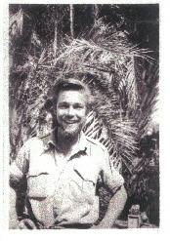

The equipment they used for navigation was well tried and effective, and included what was known as the Bagnold Sun Compass, developed by the eponymous Major Ralph Bagnold, who had fought in the trenches during the First World War, and who subsequently led expeditions in the Egyptian desert in the 1920’s and ‘30’s. Bagnold had retired from the |British Army in 1935 but had rejoined in 1940, in a short while forming the Long Range Patrol, the forerunner of the LRDG, as a scouting and intelligence-gathering unit. His Sun Compass was adopted by the LRDG as its standard instrument and its navigators became renowned for their mastery of desert navigation.

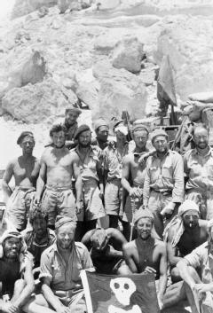

The sun compass could be described as a portable sun dial, with tables of azimuth values to establish the true direction in which the patrol was headed. Naturally, the desert conditions did not allow of travel in a straight line; obstacles such as rock outcrops, swamp or soft sand had to be circumvented. The navigator had to record every deviation in course and each leg’s distance travelled so that a dead reckoned position could be calculated at the end of the day. The sun compass was a beautifully accurate instrument and in desert conditions far superior to the magnetic compass.

At dusk, the navigator used a theodolite to measure the altitudes and azimuths of selected stars (and he had to know his stars), from which by means of astronavigational tables and the nautical almanac or air almanac (“Which was easier,” says Jim) the patrol’s position was calculated by him.

“I would shoot three stars and finish up with a small triangle on my map – we would be in the centre of that triangle.”

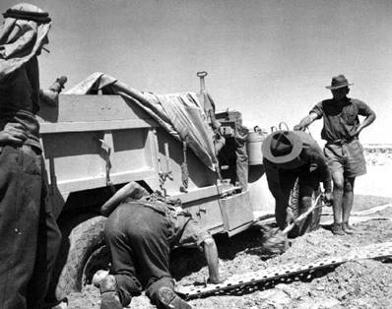
Digging out a truck in soft sand

For the rest of the desert campaign, navigation was Jim’s job, and craft. His patrol got involved in skirmishes from time to time, but it was mostly reconnaissance that they carried out: of the enemy’s base regions; and keeping a watch on that coast road, the only one in North Africa capable of carrying the immense heavy traffic that is the lifeblood of any campaign.

Usually the patrol would be sited just a couple of miles from the coast road, camouflaged. Two men would be sent forward to the road itself, hidden in a sort of bird watching hide. They would note down all that passed. In this way they were able to discern whether the enemy was planning attack or retreat. The information was of immense value to army commanders in deploying troops as the campaign progressed.

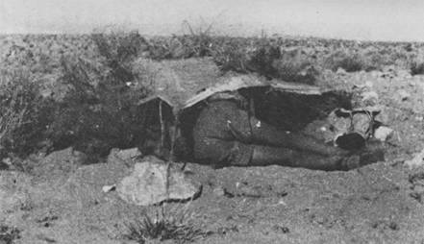
Observer hidden on the Road Watch

There was one major offensive in which Jim’s patrol was involved. This was in September 1942 when simultaneous attacks were made on three coastal towns, namely Barce, Benghazi and Tobruck. The attack on Barce was made by a New Zealand patrol of the LRDG and was a success. The attack on Tobruck, which was initially planned to be carried out by the LRDG alone, was a bad failure. Senior planners threw forces from the RAF, Navy and Army into the attack, the enemy obtained advance knowledge of it through breaches of security and the result was the loss of three naval vessels and many casualties among naval and army personnel.

Jim was involved with Y patrol whose part in this was to prevent reinforcements entering Tobruck during the attack, a task which they performed well but the attack was a tragic failure.

The attack on Benghazi was made by the SAS and resulted only in limited success.

During the desert campaign the LRDG occupied a number of different bases apart from Siwa. The main one of these was Kufra, an oasis similar to Siwa but in Libya, further south and west than Siwa. Other bases occupied were Jalo, Zella and Hon at various times.

The desert campaign was concluded in early 1943, and Jim and his colleagues prepared for a very different role. Read about this in the next edition of Jim’s reminiscences......

